FOOD SAFETY AND HYGIENE PRACTICES
AMONG STREET FOOD VENDORS
IN PATNA, BIHAR
A Primary Research Study

Submitted to:
Department of Economics | St. Xavier’s College of Management & Technology | Patna

Study Area: Patna, Bihar, India
Sample Size: 50 Street Food Vendors
Year: 2026

Research by:

¹Md. Aatir Usmani (64), ²Akshay Kumar Pandey (60), ³Suhani Kumari Gupta (63)

¹UG – St. Xavier’s College of Management & Technology, Patna, Bihar, India
²UG – St. Xavier’s College of Management & Technology, Patna, Bihar, India
³UG – St. Xavier’s College of Management & Technology, Patna, Bihar, India

¹usmaniaatir721@gmail.com, ²akshayk91818@gmail.com, ³suhanikri2505@gmail.com

Keywords: Food Safety, Street Food, Hygiene Practices, Patna, Foodborne Diseases, Sanitation

ABSTRACT
Street food vending is an integral component of urban food culture in India, providing affordable nutrition and livelihood opportunities to millions of low-income individuals. Patna, the capital city of Bihar, hosts a large and diverse street food economy that serves a significant portion of the urban population daily. However, concerns about food safety, hygiene, and sanitation at street food vending sites present a persistent public health challenge. This study examines food safety and hygiene practices among 50 street food vendors in Patna city using a structured questionnaire and direct observation method. The study focuses on six core dimensions: personal hygiene of vendors, food preparation and handling practices, food storage methods, cleanliness of vending sites, waste disposal practices, and vendor awareness of food safety regulations. The study also analyses how socio-demographic factors such as education level, years of experience, and type of stall influence food safety compliance. Findings reveal that while a majority of vendors demonstrate basic food handling practices, significant gaps exist in areas such as use of protective gear, temperature-controlled food storage, proper waste management, and knowledge of the Food Safety and Standards Act (FSSAI) regulations. Educational attainment and years of experience are found to be positively correlated with better food safety practices. The study recommends a multi-pronged intervention strategy including targeted vendor training programs, awareness campaigns, improved municipal sanitation infrastructure, streamlined FSSAI licensing for informal vendors, and regular inspections by local authorities. These measures are essential to safeguard public health while preserving the economic and cultural significance of street food vending in Patna.

INTRODUCTION

1.1 Background
Street food occupies a unique and indispensable space in the social, cultural, and economic fabric of Indian cities. Defined by the Food and Agriculture Organization (FAO) as foods and beverages prepared and sold by vendors and hawkers in streets and other public places for immediate consumption, street food plays a critical role in the urban food system. Across India, an estimated 2.5 million street food vendors operate in towns and cities, serving an enormous segment of the population that relies on affordable, ready-to-eat meals.
Patna, the capital and largest city of Bihar, has a rich and vibrant street food culture. From the iconic litti-chokha and sattu, paratha to chaat, jalebi, and biryani, street food vendors in Patna serve thousands of customers daily across areas such as Gandhi Maidan, Boring Road, Patna Junction, Rajendra Nagar, and college-area markets. Street food vending provides direct livelihoods to vendors as well as indirect employment in supply chains including raw material procurement, packaging, and transportation.
Despite its economic and cultural importance, street food vending is consistently associated with elevated risks of foodborne illness. Street food preparation typically occurs in open, dusty environments lacking proper infrastructure for clean water supply, waste disposal, refrigeration, and sanitation. Vendors may inadvertently contaminate food through improper personal hygiene, use of unsafe water, inadequate cooking temperatures, cross-contamination between raw and cooked foods, and poor storage practices.

1.2 Problem Statement
Foodborne diseases constitute a major public health burden in low- and middle-income countries. In India, the National Health Profile and various epidemiological studies indicate that a significant proportion of diarrheal diseases, typhoid, hepatitis A, and other gastrointestinal illnesses are linked to consumption of unsafe street food. In Bihar specifically, limited municipal infrastructure, lower literacy levels, and inadequate enforcement of food safety regulations exacerbate the risk.
While national-level studies on street food safety exist, there is a paucity of micro-level, city-specific research from Patna that examines actual vendor practices on the ground. Understanding the specific hygiene behaviours, knowledge gaps, and environmental conditions in Patna is essential for designing targeted, context-appropriate interventions.

1.3 Objectives of the Study
The study is guided by the following specific objectives:
- To assess the personal hygiene practices of street food vendors in Patna city.
- To examine food preparation, handling, and storage practices among vendors.
- To evaluate the cleanliness of vending sites and waste disposal methods.
- To measure vendor awareness and compliance with food safety regulations including FSSAI.
- To analyse the influence of education, experience, and stall type on food safety practices.
- To suggest actionable recommendations for improving street food safety in Patna.

1.4 Significance of the Study
This research contributes to the growing body of evidence on street food safety in Indian cities. The findings are relevant for multiple stakeholders: municipal authorities and public health departments in Patna, the Food Safety and Standards Authority of India (FSSAI), non-governmental organizations working on urban food security, and researchers studying informal food systems. By providing empirical, ground-level data, this study aims to bridge the gap between policy and practice in the management of street food safety.

1.5 Scope and Limitations
The study is confined to 50 street food vendors operating in selected areas of Patna city. The sample, while providing meaningful insights, is not statistically representative of all vendors in the city. The study relies partly on self-reported information from vendors, which may be subject to social desirability bias. Observational data collected during a single visit may not capture the full range of vendor behaviour across different times of day or seasons.

REVIEW OF LITERATURE
Street food safety has been extensively studied across the globe, particularly in developing countries in Asia, Africa, and Latin America. The World Health Organization (WHO, 2019) recognizes unsafe food as a global public health threat, estimating that approximately 600 million people fall ill each year due to foodborne diseases, with 420,000 deaths annually. A substantial portion of these cases are linked to street food consumption.[1]
Studies from Southeast Asia, including Thailand (Rheinlander et al., 2008) and Vietnam (Nguyen et al., 2015), have documented persistent gaps in personal hygiene, use of unsafe water sources, and limited temperature control among street vendors. Research from sub-Saharan Africa (Mensah et al., 2002; Barro et al., 2007) has similarly found high microbial contamination levels in street foods, often attributable to cross-contamination during handling and storage.[2]
In Latin American cities, Estrada-Garcia et al. (2004) found that street food vendors in Mexico City frequently used untreated water for food preparation, and that vendor hygiene training significantly reduced the incidence of contamination. These findings underscore the importance of behavioural interventions alongside infrastructure improvements.[3]
India presents a complex context for street food safety research. Sanlier et al. (2010) and WHO South-East Asia Region reports highlight India as a country with high burden of foodborne illness, with street food consumption being a significant risk factor. Studies conducted in Indian metros including Delhi (Chakrabarti, 2011), Mumbai (Desai & Bhatt, 2014), and Kolkata (Mukherjee et al., 2016) reveal that the majority of vendors lack formal food safety training, and that hygienic food handling is not consistently practiced.[4]
Research by Kumar et al. (2013) in Delhi found that only 32% of sampled vendors washed their hands regularly with soap between handling money and food. A study by Singh et al. (2016) in Varanasi, a culturally comparable city in Uttar Pradesh, found that 74% of vendors had no awareness of FSSAI regulations, and that fewer than 20% maintained any form of food safety documentation. Given the geographical and demographic proximity of Varanasi to Patna, these findings are particularly relevant to the present study.[5]
Multiple studies have identified education and training as key determinants of food safety behaviour among street vendors. Mathew et al. (2017) found a significant positive correlation between educational attainment and compliance with basic hygiene standards among vendors in Kerala. Vendors who had received food safety training were significantly more likely to practice handwashing, use potable water, and maintain clean vending environments.[6]

The type of stall or vending unit also influences hygiene outcomes. Fixed-location stalls with access to running water and waste disposal facilities tend to demonstrate better hygienic practices than mobile or pushcart vendors (FAO, 2009). Longer duration of experience in vending was found by Omemu and Aderoju (2008) to be positively associated with knowledge of food safety, though this relationship was moderated by access to training and regulatory oversight.[7]
The Food Safety and Standards Authority of India (FSSAI) was established under the Food Safety and Standards Act, 2006, as the apex body for food regulation in India. The Act mandates that all food business operators, including street vendors, must register with or be licensed by FSSAI. The Street Food Vendors Policy (2014) and subsequent guidelines attempt to bring informal vendors into a regulatory framework that ensures basic hygiene standards.[8]
However, implementation of these regulations at the ground level remains weak in many Indian cities. Surveys by FSSAI itself have acknowledged that a large proportion of street vendors operate without proper registration. Limited awareness among vendors, complex registration procedures, language barriers, and infrequent inspections by municipal bodies are key barriers to regulatory compliance (FSSAI Annual Report, 2022-23).[9]

2.5 Research Gap
Despite the growing literature on street food safety in India, Patna city and Bihar more broadly remain under-researched. Most existing studies are concentrated in major metros, leaving a significant gap in understanding the specific food safety conditions, vendor practices, and regulatory compliance levels in smaller but rapidly growing cities like Patna. This study addresses this gap by providing primary data from a systematic survey of street food vendors in Patna.

RESEARCH METHODOLOGY

3.1 Research Design
The study adopts a descriptive and analytical research design. A combination of quantitative and qualitative approaches is used. Primary data was collected through a structured questionnaire administered to 50 street food vendors, supplemented by direct observational assessment of vending sites. This mixed-method approach enables a comprehensive picture of both self-reported practices and actual conditions on the ground.

3.2 Study Area
Patna city, the state capital of Bihar, was selected as the study area. Patna is a rapidly growing urban centre with a population of approximately 2.5 million and a large informal food economy. Vendors were surveyed from six major food-vending zones across the city:
- Gandhi Maidan and surroundings (central Patna)
- Patna Junction Railway Station area
- Boring Road and Patliputra Colony (residential/commercial zone)
- Rajendra Nagar market area
- Kankarbagh market (eastern Patna)
- Patna University and college zones (student-heavy area)

3.3 Sampling Design
A non-probability purposive sampling technique was used to select respondents. The sample consisted of 50 street food vendors, distributed proportionally across the six study zones. Vendors were selected to ensure diversity in terms of food type (cooked meals, snacks, beverages, sweets), stall type (fixed stall, mobile cart, temporary setup), and vendor demographics (gender, age, education). Only vendors who had been operating for at least six months and were willing to participate were included.

3.4 Data Collection Tools

3.4.1 Structured Questionnaire
A structured questionnaire was developed based on WHO and FSSAI food safety guidelines and validated instruments used in similar studies. The questionnaire contained 45 questions organized into the following sections:
- Section A: Socio-demographic profile of the vendor (age, gender, education, experience, stall type)
- Section B: Personal hygiene practices (handwashing, protective clothing, health status)
- Section C: Food preparation and handling practices
- Section D: Food storage practices
- Section E: Waste disposal and site cleanliness
- Section F: Awareness of food safety regulations and training received
The questionnaire was prepared in both English and Hindi to ensure accessibility. A pilot test was conducted with 5 vendors outside the main sample to check clarity and reliability of questions, following which minor revisions were made.

3.4.2 Observation Checklist
A structured observation checklist was used by the researcher to independently assess the actual condition of each vending site, irrespective of vendor self-reporting. The checklist covered availability of clean water, visible cleanliness of utensils and equipment, presence of garbage bins, vendor use of gloves or aprons, food storage conditions, and pest control measures. Observations were cross-referenced with questionnaire responses to identify discrepancies.

3.5 Data Analysis
Quantitative data from the questionnaire was coded and entered into Microsoft Excel. Descriptive statistics including frequencies and percentages were calculated for all variables. Chi-square tests were used to examine associations between categorical variables (e.g., education level and handwashing practice). A Food Safety Practice Score (FSPS) was constructed by assigning scores to responses across all hygiene-related questions, enabling comparison of overall food safety performance across sub-groups. SPSS version 26 was used for inferential statistical analysis.

DATA ANALYSIS AND FINDINGS

4.1 Socio-Demographic Profile of Respondents
Table 4.1 presents the demographic profile of the 50 vendors surveyed in Patna city.

Variable | Category | Frequency (n=50) | Percentage (%)
Gender | Male | 38 | 76.0
 | Female | 12 | 24.0
Age Group | Below 25 years | 8 | 16.0
 | 25 – 35 years | 19 | 38.0
 | 36 – 45 years | 14 | 28.0
 | Above 45 years | 9 | 18.0
Education | Illiterate | 9 | 18.0
 | Primary (up to Class V) | 14 | 28.0
 | Secondary (Class VI–X) | 18 | 36.0
 | Higher Secondary & above | 9 | 18.0
Experience | Less than 2 years | 7 | 14.0
 | 2 – 5 years | 16 | 32.0
 | 6 – 10 years | 18 | 36.0
 | More than 10 years | 9 | 18.0
Stall Type | Fixed stall / shop | 18 | 36.0
 | Mobile cart / thela | 22 | 44.0
 | Temporary setup / footpath | 10 | 20.0
Monthly Income | Below Rs. 5,000 | 8 | 16.0
 | Rs. 5,000 – 10,000 | 21 | 42.0
 | Rs. 10,001 – 15,000 | 14 | 28.0
 | Above Rs. 15,000 | 7 | 14.0
Table 4.1: Socio-Demographic Profile of Street Food Vendors (n=50)
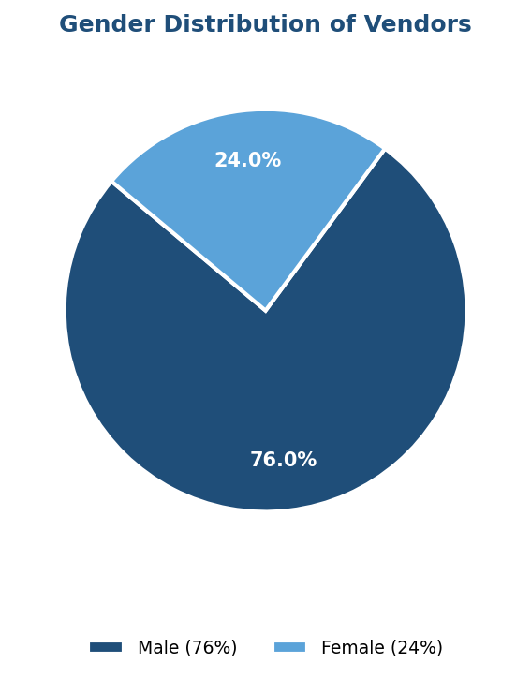
Figure 4.1: Gender Distribution of Surveyed Vendors (n=50)
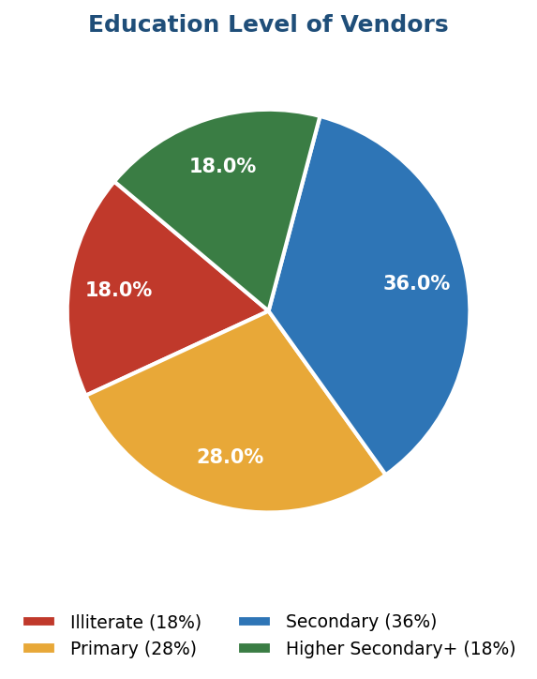
Figure 4.2: Education Level of Surveyed Vendors (n=50)
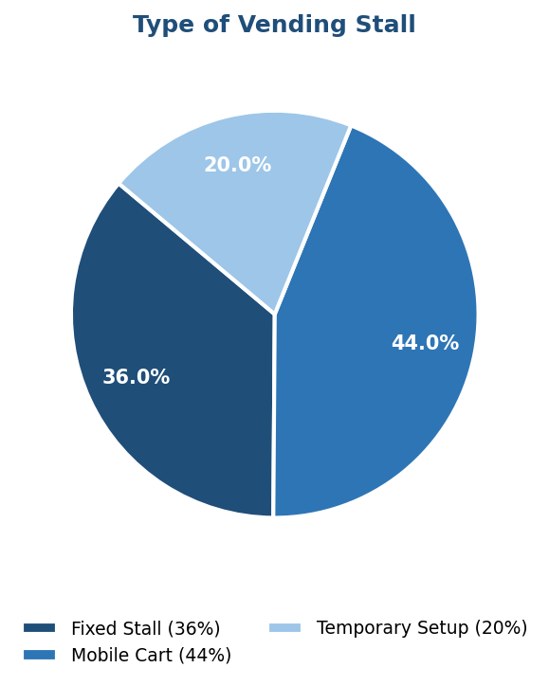
Figure 4.3: Type of Vending Stall (n=50)
The sample shows a predominance of male vendors (76%), which is consistent with the broader demographic profile of street food vending in North Indian cities. The largest age cohort is 25–35 years (38%), suggesting a relatively young workforce. Educational attainment is moderate, with 36% having completed secondary schooling; however, 18% are illiterate. Mobile carts are the most common stall type (44%), followed by fixed stalls (36%) and temporary setups (20%). A majority of vendors (58%) earn below Rs. 10,000 per month, confirming the low-income nature of this occupation.

4.2 Personal Hygiene Practices
Personal hygiene of food handlers is one of the most critical determinants of food safety. The survey assessed multiple dimensions of vendor personal hygiene.

Hygiene Indicator | Yes (%) | No (%) | Sometimes (%)
Wash hands before food preparation | 72.0 | 12.0 | 16.0
Wash hands after handling money | 38.0 | 44.0 | 18.0
Use soap during handwashing | 46.0 | 54.0 | —
Wear apron or protective clothing | 24.0 | 76.0 | —
Wear gloves while serving food | 14.0 | 86.0 | —
Keep nails trimmed and clean | 58.0 | 42.0 | —
Avoid handling food when ill | 64.0 | 36.0 | —
Cover hair while preparing food | 18.0 | 82.0 | —
Received medical check-up in last year | 22.0 | 78.0 | —
Table 4.2: Personal Hygiene Practices of Vendors (n=50)
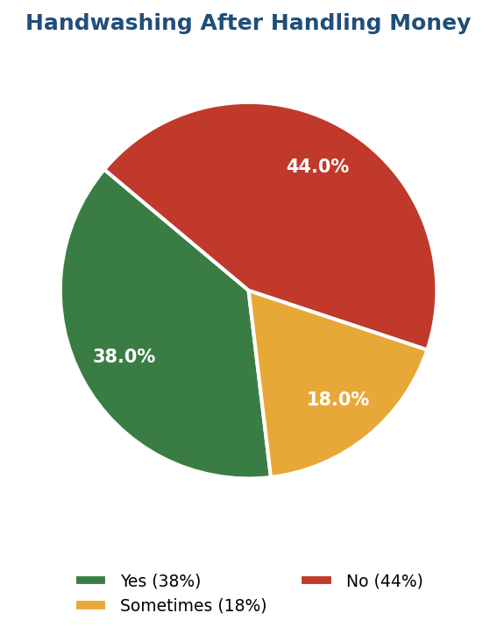
Figure 4.4: Handwashing Practice After Handling Money (n=50)
The findings reveal a mixed picture of personal hygiene practices. While 72% of vendors report washing hands before food preparation, only 38% wash their hands after handling money — a critical contamination risk given the frequency of cash transactions. The use of soap during handwashing is reported by only 46% of vendors. Alarmingly, protective equipment such as gloves (14%) and aprons (24%) are used by very few vendors. Only 22% of vendors had undergone a medical check-up in the past year, raising concerns about the potential transmission of illness through food handling.

4.3 Food Preparation and Handling Practices

Practice | Yes (%) | No (%)
Use clean/potable water for preparation | 66.0 | 34.0
Separate raw and cooked food during prep | 52.0 | 48.0
Cook food to adequate temperature | 74.0 | 26.0
Reheat leftover food before serving | 58.0 | 42.0
Cover food when not serving | 62.0 | 38.0
Use clean utensils for each batch | 54.0 | 46.0
Check expiry dates on packaged ingredients | 42.0 | 58.0
Use fresh oil (change regularly) | 48.0 | 52.0
Taste food using fingers | 38.0 | 62.0
Table 4.3: Food Preparation and Handling Practices (n=50)
Around 66% of vendors use clean water for food preparation, though 34% rely on non-potable or uncertain water sources, which is a major contamination risk. Separation of raw and cooked food — a fundamental principle of preventing cross-contamination — is practiced by only 52% of vendors. Checking expiry dates on packaged ingredients is done by only 42% of respondents, and approximately 48% do not change cooking oil regularly, which may lead to accumulation of harmful compounds. Tasting food with fingers, a behavior that can introduce contamination, was observed in 38% of vendors during the observation exercise.

4.4 Food Storage Practices

Storage Practice | Frequency | Percentage (%)
Refrigerator or cold storage | 6 | 12.0
Covered container at ambient temperature | 28 | 56.0
Uncovered container at ambient temperature | 11 | 22.0
No special storage method | 5 | 10.0
Table 4.4: Primary Food Storage Method Used (n=5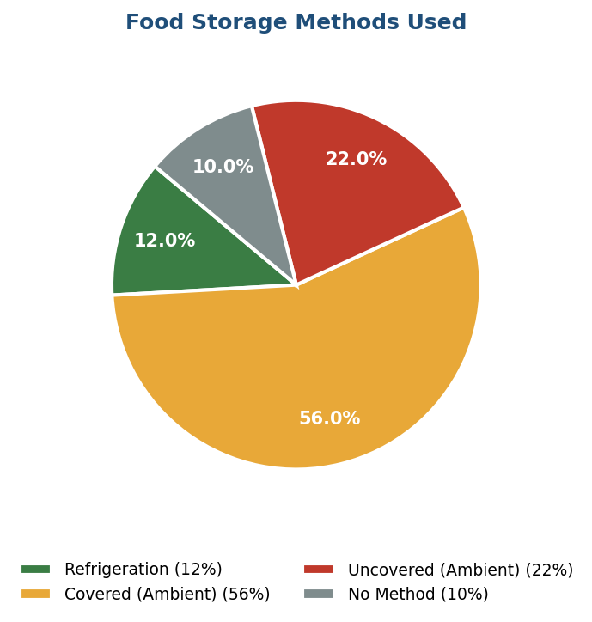
Figure 4.5: Food Storage Methods Used by Vendors (n=50)
Only 12% of vendors use refrigeration or cold storage for perishable food items — a critically low figure given the warm climate of Patna and the perishable nature of many street foods. The majority (56%) store food in covered containers at ambient temperature, which carries risk during summer months when temperatures in Patna routinely exceed 40 degrees Celsius. Twenty-two percent leave food uncovered at room temperature, creating direct exposure to dust, insects, and airborne contaminants. Ten percent use no special storage method at all.

4.5 Cleanliness of Vending Sites and Waste Disposal

Site Cleanliness Indicator | Yes (%) | No (%)
Has designated garbage bin at vending site | 36.0 | 64.0
Disposes waste in municipal bin daily | 44.0 | 56.0
Sweeps/cleans vending area daily | 68.0 | 32.0
Has access to clean water at vending site | 48.0 | 52.0
Presence of flies/insects observed | 58.0 | 42.0
Keeps drainage/wastewater away from food | 52.0 | 48.0
Cleans utensils with soap/detergent | 56.0 | 44.0
Uses separate cloth for drying utensils | 30.0 | 70.0
Table 4.5: Site Cleanliness and Waste Disposal Practices (n=50)
The observational findings paint a concerning picture of environmental sanitation at vending sites. Only 36% of vendors have a designated garbage bin at their stall, and 64% lack any formal waste disposal arrangement. During observation, flies and insects were present at 58% of vending sites, indicating inadequate pest control. Access to clean water at the vending site itself is available to only 48% of vendors — a critical deficiency that limits the ability to practice good hygiene. Daily sweeping of the vending area is practiced by 68% of vendors, which is a positive finding, though it does not compensate for the more serious deficiencies noted above.

4.6 Awareness of Food Safety Regulations

Awareness Indicator | Yes (%) | No (%)
Aware of FSSAI (Food Safety Authority of India) | 34.0 | 66.0
Holds valid FSSAI registration/license | 18.0 | 82.0
Aware of any food safety laws in India | 28.0 | 72.0
Has ever attended food safety training | 16.0 | 84.0
Received training from municipality | 10.0 | 90.0
Aware of health risks from unsafe food | 72.0 | 28.0
Willing to undergo food safety training | 88.0 | 12.0
Table 4.6: Awareness of Food Safety Regulations (n=50)
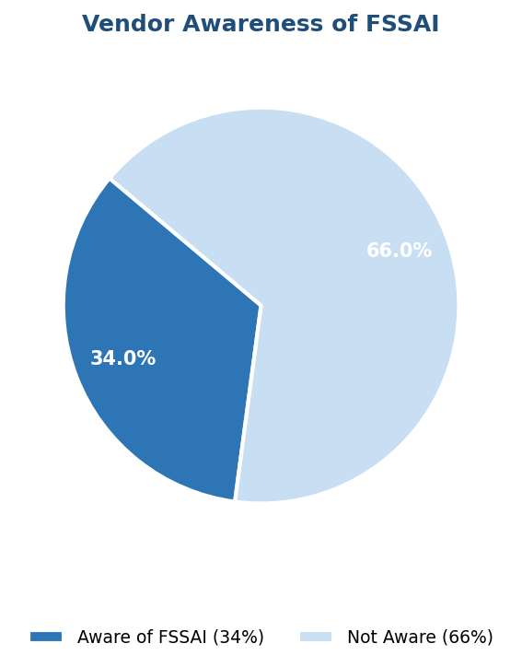
Figure 4.6: Vendor Awareness of FSSAI (n=50)
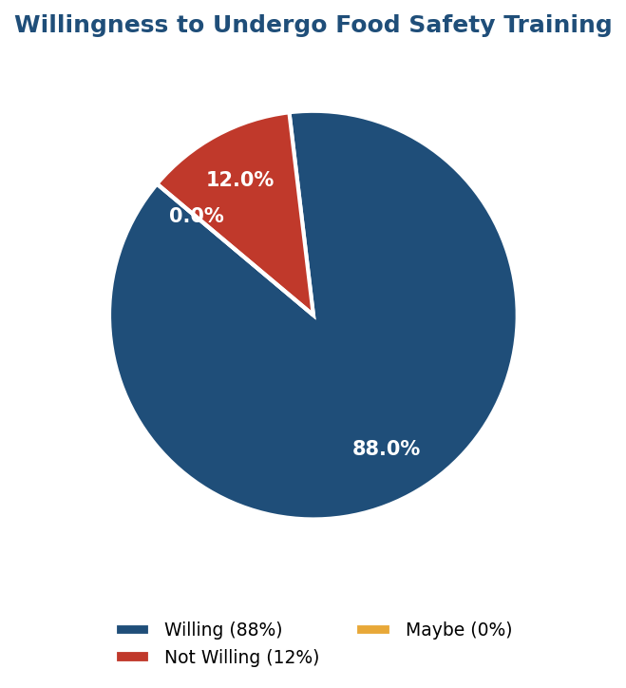
Figure 4.7: Vendor Willingness to Undergo Food Safety Training (n=50)
The awareness data reveals a major gap between vendors' general health consciousness and their regulatory knowledge. While 72% are aware that unsafe food can cause illness, only 34% have heard of FSSAI, and only 18% hold a valid FSSAI registration or license. A mere 16% have ever attended any formal food safety training, and only 10% have received training from the Patna Municipal Corporation or any government agency. However, 88% of vendors expressed willingness to undergo food safety training if offered, suggesting a strong potential for behavioral change through targeted outreach.

4.7 Influence of Education on Food Safety Practices

Education Level | Mean Food Safety Practice Score | Handwash with Soap (%) | FSSAI Aware (%)
Illiterate (n=9) | 38.4 | 22.2 | 11.1
Primary (n=14) | 46.7 | 35.7 | 21.4
Secondary (n=18) | 58.2 | 55.6 | 38.9
Higher Secondary & above (n=9) | 71.6 | 77.8 | 66.7
Table 4.7: Food Safety Practices by Education Level (n=50)
A clear positive gradient is observed between educational attainment and food safety practice scores. Illiterate vendors scored an average of 38.4 out of 100 on the composite Food Safety Practice Score, while those with higher secondary education or above scored 71.6. Awareness of FSSAI increased sharply with education, from 11.1% among illiterate vendors to 66.7% among the most educated group. Chi-square analysis confirmed that the association between education and handwashing with soap is statistically significant (p < 0.05).

4.8 Influence of Experience on Food Safety Practices

Years of Experience | Mean FSPS | Proper Storage (%) | Regular Cleaning (%)
Less than 2 years (n=7) | 41.2 | 28.6 | 57.1
2–5 years (n=16) | 50.8 | 37.5 | 62.5
6–10 years (n=18) | 59.4 | 50.0 | 72.2
More than 10 years (n=9) | 63.7 | 55.6 | 77.8
Table 4.8: Food Safety Practices by Years of Experience (n=50)
Experience is positively associated with food safety practice scores, with vendors having more than 10 years of experience achieving a mean FSPS of 63.7 compared to 41.2 for those with less than 2 years. This trend likely reflects accumulated learning from customer feedback, regulatory encounters, and peer observation, rather than formal training. However, even the most experienced vendors fall short of optimal food safety standards, indicating that experience alone is insufficient without formal training.

4.9 Influence of Stall Type on Food Safety Practices

Stall Type | Mean FSPS | Water Access (%) | Has Garbage Bin (%)
Fixed stall (n=18) | 64.3 | 72.2 | 61.1
Mobile cart (n=22) | 50.1 | 36.4 | 22.7
Temporary setup (n=10) | 39.6 | 20.0 | 10.0
Table 4.9: Food Safety Practices by Stall Type (n=50)
Fixed-stall vendors significantly outperform mobile cart and temporary setup vendors across all measured food safety dimensions. Fixed stalls have better access to clean water (72.2%) and are more likely to have a dedicated garbage bin (61.1%), reflecting the infrastructure advantages of permanent locations. Temporary setup vendors scored lowest (mean FSPS: 39.6), with only 20% having water access and just 10% maintaining any waste disposal arrangement. These differences are statistically significant (p < 0.01, chi-square test) and have important implications for targeting interventions.

DISCUSSION

5.1 Personal Hygiene Gaps
The finding that only 38% of vendors wash hands after handling money represents one of the most significant contamination risks identified in this study. In street food environments, vendors constantly alternate between handling currency and food, creating a direct contamination pathway. This finding echoes results from Kumar et al. (2013) in Delhi and aligns with WHO's identification of hand hygiene as the single most important measure to prevent foodborne illness. The low rate of glove (14%) and apron use (24%) further amplifies this risk.
The high rate of illiteracy among vendors who do not practice proper handwashing suggests that awareness campaigns must be visual and practical rather than text-based. Demonstrations, pictorial guides at vending sites, and peer-to-peer education by trained community health workers could be more effective than written materials or conventional lectures.

5.2 Critical Role of Water Access
Access to clean water at the vending site was found to be a fundamental enabling factor for good hygiene practices. Vendors with water access were significantly more likely to wash hands, clean utensils properly, and maintain cleaner vending environments. This finding reinforces the FAO (2009) emphasis on infrastructure as a prerequisite for behavioural change. Until the Patna Municipal Corporation ensures water kiosks or piped water connections near major vending zones, behavioural interventions will be limited in their effectiveness.

5.3 Food Storage and Temperature Control
The near-complete absence of refrigeration among street food vendors (only 12%) is particularly alarming in the context of Patna's climate. The city experiences extreme summer temperatures, and bacterial growth in foods left at ambient temperature accelerates dramatically above 32 degrees Celsius. Foods such as cooked rice, dahi, paneer, chutney, and meat-based items stored without refrigeration can become unsafe within hours. While the cost of refrigeration may be prohibitive for individual vendors, community-level cold storage facilities or subsidized refrigeration units through government schemes could address this gap.

5.4 Regulatory Awareness and Compliance
The finding that 82% of vendors do not hold FSSAI registration is striking but consistent with nationwide trends. The FSSAI itself has acknowledged implementation challenges, particularly among informal vendors. The current registration system, while simplified in recent years, still poses practical barriers for vendors who lack literacy, smartphones, or awareness of the process. A ward-level registration drive, conducted in local languages by trained FSSAI facilitators, could dramatically improve compliance.
The willingness of 88% of vendors to undergo food safety training represents a crucial opportunity. This high level of receptivity suggests that a demand-side barrier does not exist — the bottleneck is on the supply side, with insufficient government-sponsored training programs reaching this population in Patna.

5.5 Role of Education and Experience
The strong positive correlation between education and food safety practice scores is consistent with existing literature. Education enhances vendors' ability to process and apply food safety information, read ingredient labels, understand health risks, and navigate regulatory processes. This finding suggests that long-term improvements in street food safety will partly depend on broader improvements in educational attainment in Bihar, alongside immediate-term training interventions designed for low-literacy audiences.
The positive but more modest association between experience and food safety scores — with even the most experienced vendors falling below ideal standards — underscores the importance of formal training. Experience may instill certain routines but does not automatically generate knowledge of microbiological risks or regulatory requirements. Structured training can fill this gap more efficiently.

CONCLUSIONS AND RECOMMENDATIONS

6.1 Conclusions
This study presents a comprehensive assessment of food safety and hygiene practices among 50 street food vendors in Patna city. The findings reveal a landscape characterized by significant gaps in personal hygiene, food storage, waste management, and regulatory compliance, alongside notable variation based on vendor education, experience, and stall type. The key conclusions are:
- Personal hygiene practices are inconsistent, with particularly low rates of post-money handwashing, soap use, and protective gear usage.
- Food storage infrastructure is severely inadequate, with only 12% of vendors using refrigeration for perishable foods in a high-temperature climate.
- Awareness of FSSAI and food safety laws is limited to approximately one-third of vendors, and formal training has reached only 16%.
- Infrastructure deficiencies — particularly lack of water access and waste disposal facilities at vending sites — are major structural barriers to improved hygiene.
- Education, experience, and stall type are significant determinants of food safety practice quality, with fixed-stall vendors and more educated vendors performing markedly better.
- Despite low compliance, 88% of vendors expressed willingness to receive food safety training, indicating strong potential for behavioral improvement through outreach.

6.2 Recommendations

6.2.1 Training and Capacity Building
The Patna Municipal Corporation (PMC), in collaboration with FSSAI and the Bihar State Food Safety Department, should launch a structured Food Safety Training Program targeting all registered and unregistered street food vendors in Patna. The training should:
- Be conducted in Hindi with visual aids, practical demonstrations, and role plays to accommodate low-literacy participants.
- Cover core topics: handwashing techniques, safe food temperatures, proper storage, cross-contamination prevention, and personal protective equipment use.
- Be delivered in decentralized settings (neighborhood clusters, weekly markets) rather than requiring vendors to travel to central locations.
- Issue certificates to trained vendors, enabling them to display proof of training to build customer trust.

6.2.2 Awareness Campaigns
A citywide public awareness campaign should be designed to educate vendors and consumers on food safety. This should include:
- Display of pictorial food safety posters in Hindi at all major vending sites and markets, installed and maintained by the PMC.
- Short-duration audio-visual content on food safety broadcast through community radio, cable TV channels, and loudspeakers at market areas.
- Community health worker outreach as part of existing ASHA (Accredited Social Health Activist) and ASHA Facilitator networks in urban Patna.

6.2.3 Infrastructure Improvements
Local government authorities must prioritize the provision of basic sanitation infrastructure at major vending zones:
- Installation of clean water kiosks or taps at all identified street food clusters in Patna, with provisions for regular maintenance.
- Provision of municipal garbage bins at high-density vending sites, with daily collection to prevent overflow.
- Development of community cold storage facilities or vendor cooperative refrigeration units in major markets through PMC support or public-private partnership.
- Dedicated vending zones with basic amenities (clean water, drainage, electricity) to progressively shift vendors from purely informal to semi-formal settings.

6.2.4 Regulatory Enforcement and Simplification
- FSSAI and the state food safety department should conduct ward-level registration camps to facilitate easy enrollment of street food vendors.
- Inspections of street food vending sites should be carried out regularly by trained food safety officers, with emphasis on guidance and correction rather than purely punitive enforcement.
- A simplified, one-page registration form in Hindi and other local languages should be developed specifically for street vendors, with assistance from ward-level officers.
- Incentive mechanisms such as preferential stall allocation, subsidized equipment, or public recognition could encourage voluntary compliance with FSSAI standards.

6.2.5 Further Research
Future research should extend this study to a larger, statistically representative sample of Patna vendors and include microbiological testing of food samples to objectively measure contamination levels. Longitudinal studies tracking the impact of training interventions on food safety practices would provide valuable evidence for policy. Comparative studies across different cities in Bihar would help identify whether the patterns observed in Patna are state-wide phenomena requiring state-level policy responses.

REFERENCES
Barro, N., Sangare, L., Tahita, M. C., Tarnagda, Z., Ouedraogo, J. B., & Traore, A. S. (2007). The risk levels of street food safety in regard to hygienic and food quality in Ouagadougou, Burkina Faso. Pakistan Journal of Nutrition, 6(2), 153–159.
Chakrabarti, R. (2011). Street food vending in India: Regulatory challenges and policy implications. Economic and Political Weekly, 46(39), 30–37.
Desai, M., & Bhatt, R. (2014). Microbiological quality of street food sold near schools in Mumbai. International Journal of Food Science and Nutrition, 65(3), 311–315.
Estrada-Garcia, T., Lopez-Saucedo, C., Thompson-Bonilla, R., Abonce, M., Lopez-Hernandez, D., & Santos, J. I. (2004). Association of diarrheagenic Escherichia coli plasmid content with food and water contamination. Applied and Environmental Microbiology, 70(4), 2441–2449.
Food and Agriculture Organization of the United Nations (FAO). (2009). Good hygienic practices in the preparation and sale of street food in Africa: Tools for training. FAO Regional Office for Africa.
Food Safety and Standards Authority of India (FSSAI). (2022). Annual Report 2022–23. Ministry of Health and Family Welfare, Government of India.
Kumar, A., Bhatt, R., & Singh, S. (2013). Street food safety: A study of vendors in selected markets of Delhi. Indian Journal of Community Medicine, 38(2), 104–108.
Mathew, A., Sureshkumar, P., & Varghese, R. (2017). Food safety knowledge and practices among street food vendors in Kerala. National Journal of Community Medicine, 8(5), 258–263.
Mensah, P., Yeboah-Manu, D., Owusu-Darko, K., & Ablordey, A. (2002). Street foods in Accra, Ghana: How safe are they? Bulletin of the World Health Organization, 80(7), 546–554.
Mukherjee, S., Tripathi, B., & Roy, D. (2016). Assessment of food safety practices among street food vendors in Kolkata. Journal of Environmental Health, 78(9), 46–53.
Nguyen, P. H., Nguyen, K. C., Nguyen, T. D., Le, M. B., Bern, C., & Flores, R. (2015). Hygiene and sanitation practices of street food vendors in Ho Chi Minh City, Vietnam. Food Control, 55, 203–209.
Omemu, A. M., & Aderoju, S. T. (2008). Food safety knowledge and practices of street food vendors in the city of Abeokuta, Nigeria. Food Control, 19(4), 396–402.
Rheinlander, T., Olsen, M., Bakang, J. A., Takyi, H., Konradsen, F., & Samuelsen, H. (2008). Keeping up appearances: Balancing food safety and food quality in street food vending in Kumasi, Ghana. Journal of Urban Health, 85(6), 949–960.
Singh, R., Kumar, P., & Mishra, A. (2016). Street food safety practices and vendor awareness in Varanasi city. Indian Journal of Public Health, 60(3), 231–236.
World Health Organization (WHO). (2019). World Food Safety Day 2019 – Food Safety: Everyone's Business. World Health Organization.

